< Your logo >

< Optional: Add the Checkout Graphic here >
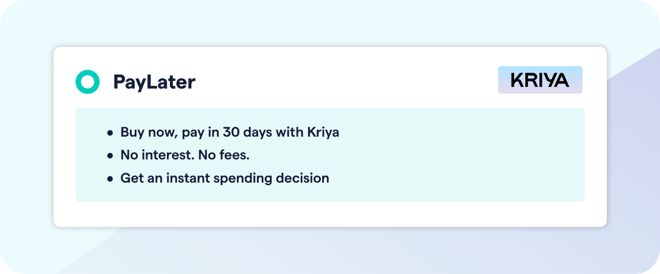

Buy now, Pay in 30 days on business purchases

Hi < Customer First Name >,

We’re excited to offer you a new way to pay for your business purchases. We’ve partnered with Kriya to offer you 30 day payment terms on your orders with us.

Buy what you need today, and pay 30 days after purchasing to keep your cash flow running smoothly.

How can I pay using Kriya?

- Place order: Head to our website, fill your basket and select Kriya from the payment options at checkout.
- Get a spending limit: Apply by providing a few business details. If eligible you’ll instantly be provided a spending limit.
- Pay in 30: We’ll ship your goods and Kriya will remind you via email when it’s time to pay.

< Optional: Add a call to action button and link to your Kriya landing page >
Find out more about Pay in 30 with Kriya

< Optional: Add your normal sign off and footer here >

