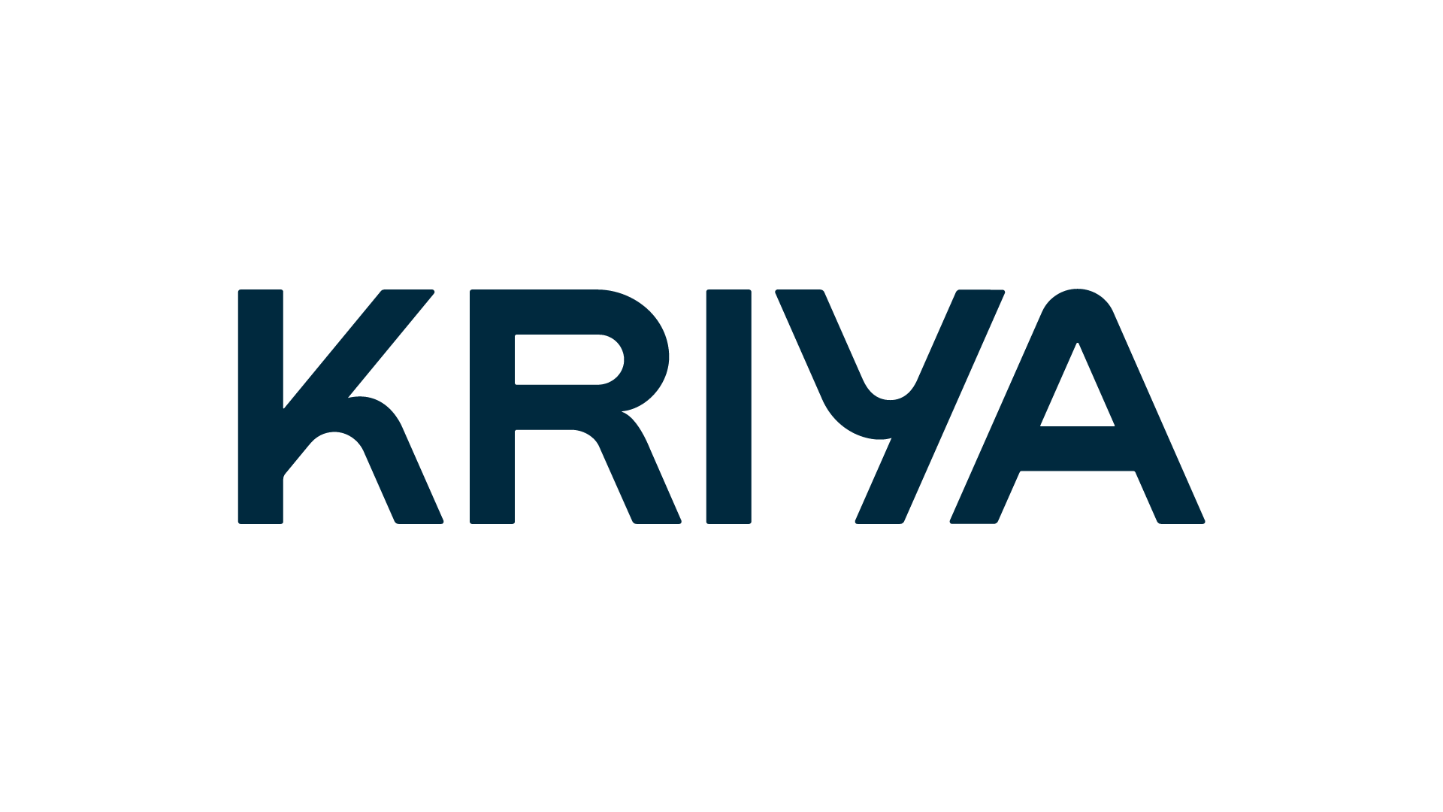

# Buy what you need today Pay for it later

We’ve partnered with Kriya to offer you flexible payment terms on your orders.

## Why use Kriya PayLater?

We know that having flexibility around when you pay is essential to keep your business flowing.

That’s why we’ve teamed up with Kriya to offer our customers a dedicated spending limit with flexible, interest-free repayments.

|  |  |  |
| --- | --- | --- |
| Instant spending decision | Pay in 30 | No fees |
| It’s easy to apply and you’ll typically get a decision instantly. Applying won’t affect your credit score. | Pay 30 days after purchasing and keep your cash flow running smoothly. | No interest and no transaction fees. |

## How it works

Get a spending limit and payment terms directly at checkout. On your first order with Kriya PayLater you’ll need to apply for a spending limit for your business. You can skip this step for future purchases.

|  |  |  |  |
| --- | --- | --- | --- |
| 1. Place order | 2. Get a spending limit | 3. Pay in 30 | 4. Order complete! |
| Fill your basket and select Kriya PayLater at checkout. | The first time you use Kriya PayLater you’ll need to provide some information about your business.  If eligible, you’ll instantly be provided a spending limit. | Choose **Pay in 30** days to purchase what you need now and not pay a penny for 30 days. | Your order is complete. Kriya will remind you when payment is due in 30 days. |

## Can I apply?

Limited businesses, sole traders and government organisations are eligible to apply for Kriya PayLater.   
Your business must have been trading for 12 months or more.

## Try Kriya PayLater now!

Apply for a spending limit and get 30 day payment terms at checkout today.

## Frequently Asked Questions

**Does using Kriya affect my credit score?**

To assess your eligibility for using Kriya PayLater, a soft credit search is performed against your business, or if you’re a sole trader or partnership, you as an individual. A soft credit check will not impact your credit score.

If you are eligible, the first time you make a purchase with Kriya PayLater, a hard search will be made. This will only happen the first time you use the service. This search will appear on your credit report. Multiple hard searches in a short period of time may affect your credit score.

**How does the payments process work?**

Choosing to pay using Kriya PayLater means you can defer paying for goods and services until a later date. The way this works is that the cost of your order is covered upfront by Kriya, and you have extended payment terms to repay the balance.

Kriya has provided a bank account in < Your Business’s> name specifically for PayLater orders. Once payment for your order is due, you’ll be required to pay the balance into this bank account. The details will be on your < Your Business > invoice.

Please note, paying <Your Business> back directly could mean delays in reinstating your spending limit.

**What does it cost?**

Choosing to pay with Kriya PayLater is free. There are no transaction fees involved, and no interest charged.

However, if you are overdue in paying your invoice you may be subject to a late payment charge. Late payments can also negatively impact your Kriya PayLater spending limit.

**What if I miss the due date?**

If you miss the due date, you will receive a reminder email. Please note that late payment fees may apply if invoices remain overdue for an extended period.